Dr Helen Osborn  DRCOG DFFP FRCGP  Dr Hussein Alibhai  MD FRCGP  Dr Kate Craufurd  MBBS MRCGP  Dr Katie Binns  MB BCh MRCGP |   COURTYARD SURGERY  39 High Street, West Lavington  Devizes, SN10 4JB  T: 01380 813300  E:courtyardsys.wiltshire@nhs.net  www.courtyardsurgery.co.uk

Patient Newsletter Autumn 2026

The Clinical Team

Dr Helen Osborn is the nominated GP for all our patients. She has clinics throughout the week.

Dr Kate Craufurd, is with us on Wednesdays & Fridays.

Dr Hussein Alibhai is with us on either a Thursday or a Friday, alongside working from home Monday to Wednesday.

Dr Katie Binns is with us on Mondays, Tuesdays and some Thursday’s.

Dr Saad Kazi is a GP registrar who will be with us for a few months.

Visiting Locums – we have regular locums, Dr Peter Phillips and Dr Anne Lashford.

Nurse Naomi D’Alessandro – is our new Practice Nurse. Naomi will be with us on Tuesday, Wednesday and Thursday. She is being supported by Nurse Rebecca Clinch, who is Practice Nurse at Hindon Surgery, and is providing support to us until the end of November.

Lisa-Marie Drewitt – is our Assistant Practitioner – Lisa provides a ranging of nursing services and also supports the Leg Club in Devizes. She is here Monday – Wednesday and Friday.

Sharon Bailey is an experienced healthcare assistant who deals with blood tests, dressings, INR tests for those on warfarin, health checks and various other injections.

Becky Seager is a former Registered Nurse returning part-time to General Practice as a GP Assistant providing bloods, ECG and Blood Pressures and injections.

Extended Care Team

Christina Smith, Sara Bailes, and Xanthe Vanderputt are our extended care team and Social Prescribing Link Workers, providing help and support for patients here and at The Orchard practice. They each have specialist skills and knowledge.

Social prescribing link workers connect people to community-based support, including activities and services that meet practical, social, and emotional needs that affect their health and wellbeing. This includes connecting people to statutory services for example housing, financial and welfare advice.

The Patient Liaison & Support Team

Dawn Currell (Team Leader), Kelly Dickinson, Amy Garrett, Janie Keating and Sharon White form our Patient Liaison Team.

They are your first point of contact, answering phones and reading the electronic messages and e-mails that you send. They triage all the messages and pass them to the person best suited to handle your problem. This may mean that they will pass you to one of the Social Prescribing or Nursing Team members, rather than you having to see a doctor first.

They prepare your prescriptions for signing and the detail of referrals, amongst 101 other tasks that help you get the best care.

Nicky Hughes Practice Manager. Nicky has joined us to steer the team, look at ways of improving the service we provide our patients.

Colin Osborn Data, IT and Finance Manager, providing support and help wherever needed.

Geraldine Kercher is our amazing cleaner, who keeps the surgery clean and tidy.


FLU & COVID Clinic Sat 3rd October

Flu and Covid vaccinations are available from the start of October. We will start vaccinating on Saturday October 3rd, and have started sending out invitations.

You are eligible for Flu Vaccination at Courtyard Surgery if:
You are aged 65 or over by 31st March 2027.

Or you are aged 18 to 64 with:
- Chronic Heart Disease
- Morbid Obesity
- Immunosuppression
- No Spleen or misfunctioning spleen
- Chronic Kidney or Liver Disease
- Chronic Neurological Disease or some learning disabilities.
- A Chronic Respiratory Disease
- Diabetes or Adrenal Insufficiency

Or:
- You are a carer
- You live with someone who is immunosuppressed
- You are a Health or Social care Worker
- You are a Care Home Resident, or you work in a care home for older or younger people
- You are homeless.

You are eligible for COVID Vaccination at Courtyard Surgery if:
- You will be 75 by January 1st 2027
- Or you are aged over 18 and have a weakened immune system because of a health condition or treatment.
- Or you live in a care home for older adults.

If you believe that you are in one of these groups but have not had an invitation or a pharmacist says you have to pay, then contact us by e-mail at Courtyardsys.wiltshire@nhs.net saying why you think you are eligible and we will assess you against the criteria for vaccination.

The NHS wants to do everything it can to ease winter demand after back-to-back heatwaves have seen staff treat record numbers this summer.
A&E attendances hit a record 2.5 million attendances in July – and staff experienced the 3 busiest months ever recorded between May and July in emergency departments.

Despite the record pressure, more patients were seen, treated or discharged within 4 hours than in June, with performance improving to 75.4%.
Flu season usually peaks in December and January, so the NHS is starting vaccinations in autumn, to ensure those at risk are protected and fewer people are hospitalised.

Flu can cause significant issues for children, pregnant women, older adults and people with some long-term health conditions, including hospitalisation and, in certain cases, severe respiratory failure or even death.

Around 104,000 hospitalisations are estimated to have been avoided last year. Last winter, nearly 19 million people received their flu jab in England.

The jab is given in injectable form in the vast majority of cases, and a nasal spray is provided for most children.

Thank you to everyone who completed the GP Patient Survey.

255 of our patients were randomly picked by the NHS and 105 completed the survey – a 41% completion rate.

83% of those who responded said that they had a ‘Very good’ overall experience of Courtyard Surgery, with 6% of respondents saying fairly good. That compares very well against the national response that 46% of patients say that their GP is very good.

Accessing the Practice

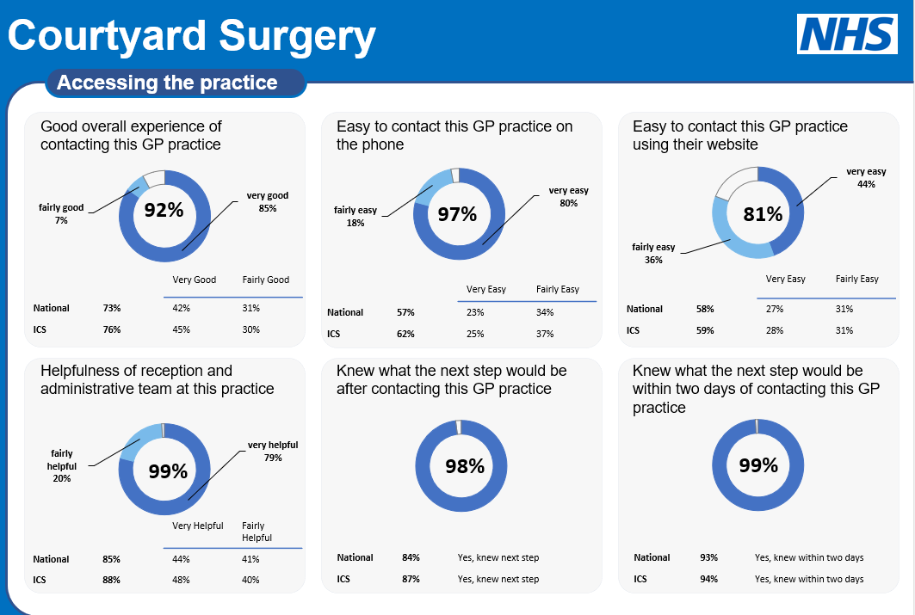

Patient Experience at the last appointment

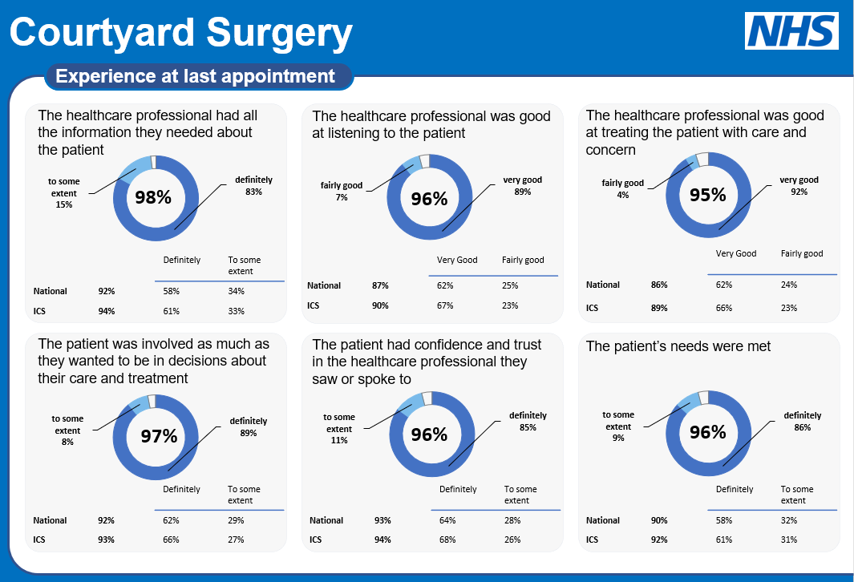

Thank you again to those of you who completed the survey.

We place a lot of importance on the results and use them to help us continue to improve our services.
Registering with us.

Like many practices you can register with
us using a link from our website or going to
https://gp-registration.nhs.uk/J83619/gpregistration/landing

You can also register via the Airmid, NHS Apps.

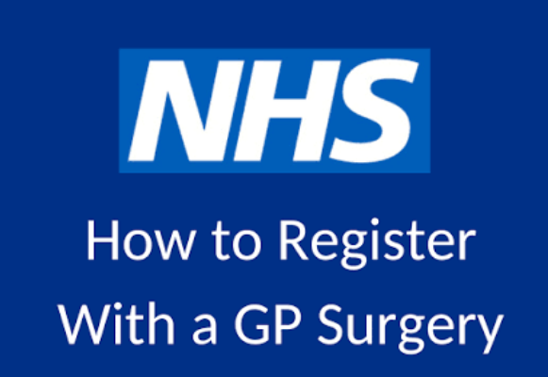

WHERE TO GO FOR MEDICAL HELP

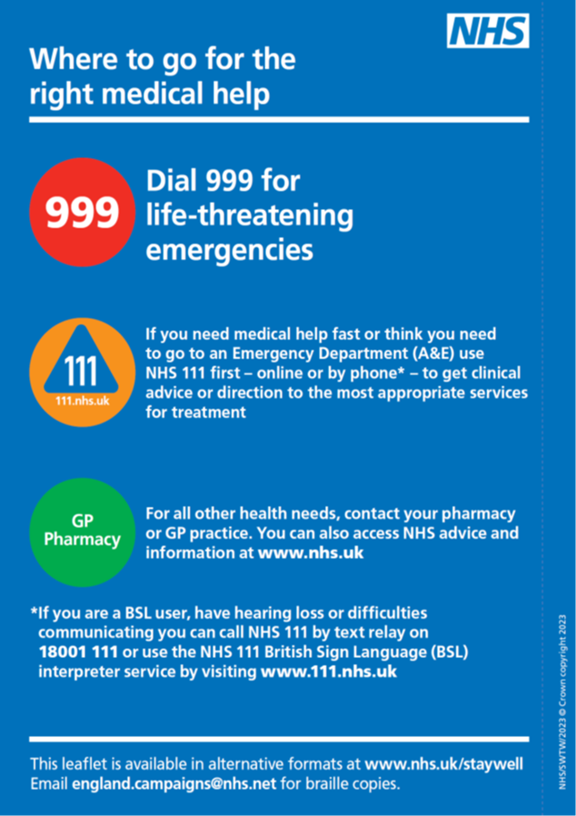

Ordering prescriptions, the process

The most effective and safest way to order your prescriptions is via email into the surgery on courtyardsys.wiltshire@nhs.net , or using the NHS or Airmid App.

We do not take prescriptions over the telephone.

Repeat Prescriptions
When ordering your repeat medication, please tell us exactly which items you need rather than requesting "everything on my repeat prescription". This helps us ensure the correct medicines and tablet strengths are issued and reduces the risk of errors.
If you have built up a surplus of any medication, please do not order that item again until your current supply has been used.
If your medication review requires a blood test or blood pressure check, please contact the surgery around three weeks before your prescription is due. You can email us or telephone the surgery, and we will arrange an appointment if needed.
We can now offer most blood test appointments between 8:00am and 3:30pm. For patients who need an early appointment because of work or other commitments, we also run a dedicated blood test clinic from 7:30am on Monday, Tuesday and Friday.

Medication and Holidays
If you are going on holiday and need your medication before you travel, please contact your usual pharmacy, who may be able to arrange an early collection of your repeat prescription.

Forgotten Medication While on Holiday in England
If you forget your medication while holidaying in England, please contact NHS 111. The NHS 111 service can assess your needs and, where appropriate, arrange an emergency supply of medication through a local pharmacy.
You can access NHS 111:
- Online at 111.nhs.uk
- By calling 111
Please note that the surgery is not usually able to arrange emergency prescriptions for patients who are away from home, and NHS 111 is the quickest and most appropriate route for obtaining urgent medication while travelling within England.

Emergency Prescriptions
We understand that occasionally patients may run out of medication unexpectedly. However, emergency prescription requests place significant pressure on practice staff and can delay care for other patients.
Please help us by ordering your repeat medication in good time. As a general guide, we recommend requesting your medication when you have around 7 days' supply remaining.
Our emergency prescription service is intended only for medication that cannot be safely missed. Not all medicines qualify as emergency medications. Details of which medications are considered urgent and our emergency prescription policy can be found on the Courtyard Surgery website.
If you are away from home and need an urgent supply of medication, please contact NHS 111 or visit 111.nhs.uk, where the NHS Emergency Prescription Service may be able to help.

